TVH invest in a new automated shuttle based Distribution Centre with TGW
Increased volumes and lack of storage space proved to be undeniable reasons for TVH to partner with TGW in an expansion of its current distribution facility.
The TVH Corporation is a family owned company, headquartered in Waregem, Belgium, and distributes parts for materials handling equipment around the world. As the world’s biggest one-stop shop, the company ensures that goods are delivered to your door within the shortest time possible.
In 2014 from the existing facility in Waregem, 540 employees processed 8,000 orders per day. The number of stored items reached 500,000. Due to the growing volumes of orders and increased numbers of stored items, to ensure future demand will be met and sustain growth, TVH will be building a 12,000 square metres automated Distribution Centre from which orders will be picked, packed and shipped. The new distribution center is to increase the TVH customer service by increasing stock lines and improve throughput to strengthen TVH’s market position. The new Distribution Centre is an addition to the existing facility which will remain part of the overall operation, the two facilities will be linked via a bridge structure.
TGW have been selected as the TVH automation partner and will integrate a TGW STINGRAY shuttle storing plastic totes. The total STINGRAY shuttle system will have 13 aisles and 50 levels. TVH will be able to store more than 400,000 totes in the 25 metre high shuttle block.
This “pick engine” will deliver stock totes to the goods to person pick-stations. A TGW KingDrive® conveyor network will connect all the storage and operational areas together. TGW Natrix sorters also form part of this conveyor network. The new Distribution Centre will go-live in 2019.
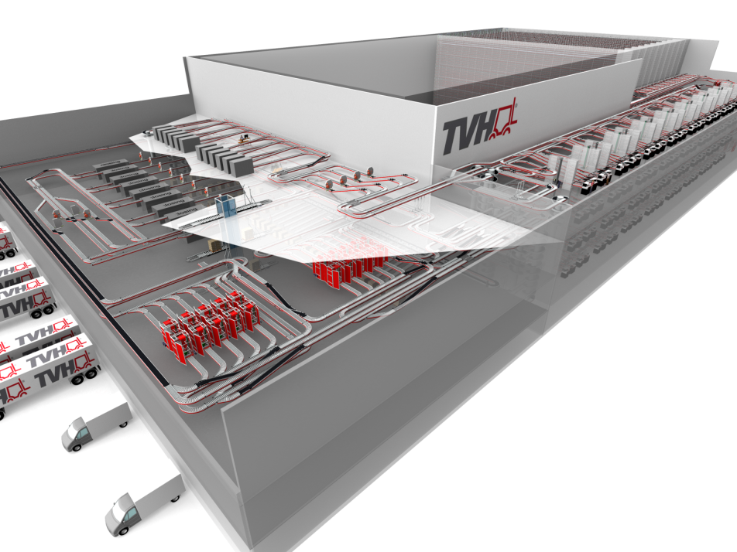

www.tgw-group.com

About TGW Logistics Group:
TGW Logistics Group is a global leading systems provider of highly dynamic, automated and turn-key logistics solutions. Since 1969 the company has been implementing different internal logistics solutions, from small material handling applications to complex logistics centres.
With about 2,500 employees worldwide by now, the Group implements logistics solutions for leading companies in various industries. In the business year 2014/15, the TGW Logistics Group generated sales revenues of 475 million Euros.
Pictures:
Reprint with reference to TGW Logistics Group GmbH free of charge. Reprint is not permitted for promotional purposes.

Contact:
TGW Logistics Group GmbH
4600 Wels, Collmannstraße 2, Austria
T: +43.7242.486-0
F: +43.7242.486-31
e-mail: tgw@tgw-group.com

Press contact:
Martin Kirchmayr Daniela Nowak
Marketing & Communication Manager Marketing & Communication Specialist
T: +43.(0)7242.486-1382 T: +43.(0)7242.486-1059
M: +43.(0)664.8187423
martin.kirchmayr@tgw-group.com daniela.nowak@tgw-group.com

