TGW Logistics Group was awarded the silver Austrian Export Prize 2017

Wels, 28th of June 2017 - success for TGW Logistics Group: the Upper Austrian company was awarded the silver Austrian Export Prize in the Industry category. With this award the AUSSENWIRTSCHAFT AUSTRIA (foreign trade) of the Austrian Economic Chambers (Wirtschaftskammer Österreich - WKO) honours Austria's top exporters and the higher-than-average dedication and successes of Austrian companies operating abroad. The Austrian Export Prize was awarded for the 23rd time. The prestigious Export Prize is awarded to companies that distinguish themselves in selected categories. A jury evaluated the performances.

"We are happy about the Austrian Export Prize and are proud of our employees who made the international success of TGW possible" Thanks to the fast growth of TGW Logistics Group, a new company site is being built in Marchtrenk, Austria, which is supposed to ensure further growth of the Group. We are always looking for motivated employees to strengthen our international team," says Georg Kirchmayr, CEO of TGW Logistics Group.
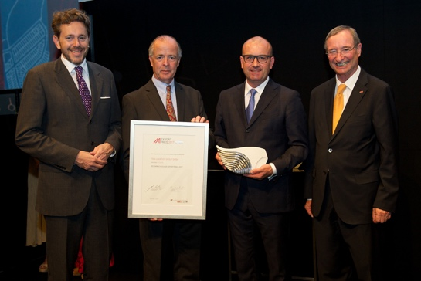

Picture (from left): Harald Mahrer/Federal Minister of Science, Research and Economy; Vice Division Chairman of Veit Schmid-Schmidsfelden; Georg Kirchmayr/CEO TGW Logistics Group; Christoph Leitl/President of the Austrian Economic Chambers
Copyright - Frank Helmrich
Reprint with reference to TGW Logistics Group GmbH free of charge. Reprint is not permitted for promotional purposes.

Contact:
TGW Logistics Group GmbH
4600 Wels, Collmannstraße 2, Austria
T: +43 7242.486-0
F: +43 7242.486-31
e-mail: tgw@tgw-group.com
www.tgw-group.com

Press contact:
Martin Kirchmayr
Marketing & Communication Manager
T: +43.7242.486-1382
M: +43.664.8187423
martin.kirchmayr@tgw-group.com

Reichl und Partner PR GmbH
Michael Obermeyr
T: +43 664 2505817
michael.obermeyr@reichlundpartner.com

