One-Billion Mark in Order Intake within reach

- Turnover reaches EUR 719.6 million
- As of 30 June 2019, number of employees increases to 3,415 worldwide
- Billion-euro barrier in incoming orders is within reach
- In the current financial year, TGW is looking to achieve a turnover of more than EUR 800 million

(Marchtrenk, Upper Austria, 4 October 2019) The TGW Logistics Group, headquartered in Marchtrenk, Upper Austria, has successfully completed the 2018/2019 fiscal year (1 July 2018 to 30 June 2019). Intralogistics specialist TGW has increased turnover to 719.6 million euros, while the number of TGW employees has risen by 250 to 3,415.

TGW is pleased to announce a new order intake all-time high in the company's 50-year history. In the 2018/19 financial year, orders at a volume totaling 920 million euros were closed. Harald Schröpf, CEO of TGW Logistics Group, confirms:

“Last year, a large number of international customers commissioned TGW with the automation of their intralogistics systems. With sports equipment specialist Puma, we were able to secure one of the largest orders in our company's history, and large domestic companies such as Kellner&Kunz rely on our know-how as well. If everything goes well and general conditions are favorable, we hope to exceed the one billion euro threshold for new orders in the current fiscal year.”

EBIT in 2018/19 totaled EUR 27.9 million, compared with EUR 36.6 million in the previous financial year. While a targeted increase in investments on behalf of employees (training and continuing education as well as investments at production sites) took place, a number of orders had to be deferred due to, among other things, uncertainties related to Brexit, which has led to intermittent capacity utilization fluctuations as related to production and manufacturing. In addition, TGW has increased its research and development expenses on a sustainable basis. The costs of preparing for the introduction of SAP have also had an impact on financial results.
Figures for the 2018/19 financial year

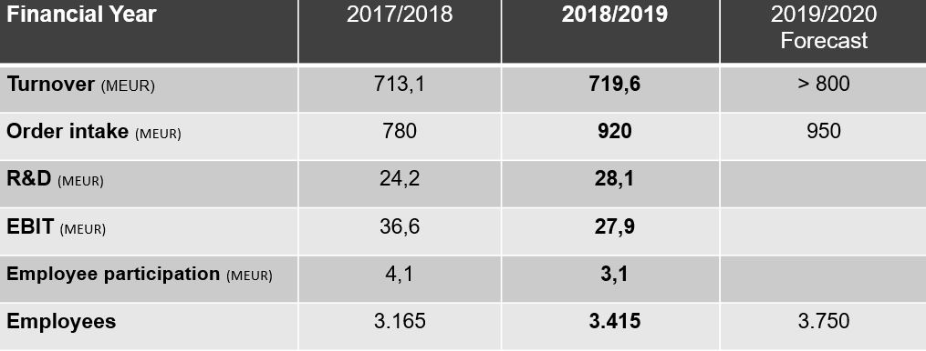

Investing in employees

The continued growth of TGW Logistics Group can only be achieved with ongoing and targeted investments in employees. In the past fiscal year, 250 new jobs were created, about half of them at the Upper Austrian locations of Marchtrenk, Wels, and Rohrbach.

In the 2018/19 fiscal year, TGW invested more than EUR 3.5 million in training and continuing education provided by the international TGW Academy. Very large and complex projects require a high level of employee know-how and rapid acquisition of knowledge.

In Marchtrenk, TGW set up both a company childcare center and a 9,000 m² outdoor area for leisure, sports, and meetings called the Activity Garden, a quite unique feature for a business. Employees and their families can now use this extensive “green gym” with a motoric park, a sports field, a running track, and barbecue areas in their leisure time and on weekends. In addition and for the second time in company history, TGW is paying out an employee participation of 3.1 million euros for the 2018/19 financial year. Harald Schröpf emphasizes:

"Highly trained and motivated employees are the cornerstone of our current as well as our future success in this dynamic industry and challenging project business. For this reason, we have invested more than ten million euros in our employees for training and continuing education, company childcare, in the Activity Garden for sports and leisure, and the Dual Employee Participation Program.”

The company childcare center “Zwergennest” in Marchtrenk first opened its doors in autumn of 2018. It is now in full operation and has been very well received by employees. At this facility, children are looked after between ages 1 and school age in special groups for toddlers, kindergarten-aged kids, as well as in age-extended groups. The Upper Austrian College of Education developed this innovative childcare concept together with and especially for TGW. For children between ages five and eleven, TGW also offers full child care during summer vacation months.

160 young TGW apprentices

In September 2019, TGW opened a new training workshop in Wels. The building near the Welas shopping center is now the workplace of 160 young men and women completing their apprenticeship at TGW. It offers a great infrastructure with new machinery and state-of-the-art equipment. Also, during the summer months, more than 130 schoolchildren and students gained their first work experience as part of their holiday internships.

EUR 28.1 million for research and development

In addition, TGW has invested sustainably in its future and new pioneering solutions, as Harald Schröpf explains:

“TGW has increased its research and development budget by more than 16 percent to EUR 28.1 in the past financial year. We are continuing along this path with a special focus on software, system solutions, robotics, and digitization. TGW provides answers to the challenges faced by many of our customers and we have positioned ourselves as the technology leader in the fields of robotics and automation.”

An international team of experts is working in an interdisciplinary competence center in Wels, Upper Austria, on innovative solutions for digitization, artificial intelligence, and robotics. These specialists have been developing a so-called digital twin for Rovolution, which is TGW´s innovative picking robot. The digital twin is a complete digital image of the real system. It can be used to analyze data, learn from it, and visualize such data.

This makes it possible to monitor the current status of Rovolution, but its replay function can also be used to look back into the robot’s history in order to identify the causes of errors. In addition, in the future it will be possible to predict very precisely when, for example, specific maintenance work needs to be carried out.

New plant in the USA, and expansion at TGW Robotics

TGW USA's new building in Norton Shores, Michigan, covers an area of 17,000 square meters and includes state-of-the-art offices and a large production hall to double production capacity. In addition, the site offers sufficient headroom for further growth.

The automation specialists at TGW Robotics in Stephanskirchen, Bavaria, have also expanded their facilities by a new production hall and offices.

About TGW Logistics Group:
TGW Logistics Group is a worldwide leading provider of intralogistics solutions. For almost 50 years this Austrian specialist has been providing automated systems for international customers from A as in Adidas to Z as in Zalando. As a systems integrator, TGW provides planning, production, and implementation of complex logistics centers – from mechatronics to robotics and from control systems to software solutions.

With more than 3,500 employees worldwide, TGW Logistics Group has offices in Europe, China, and in the USA. In the 2018/2019 business year the company achieved a total turnover of € 719 million.

Reprints:
Images reprinted for press reports featuring primarily TGW Logistics Group may be used free of charge and under citation of the source. No free reprints for promotional purposes.

Contact:
TGW Logistics Group GmbH
A-4614 Marchtrenk, Ludwig Szinicz Strasse 3
Ph: +43.(0)50.486-0
F: +43.(0)50.486-31
Email: tgw@tgw-group.com

Press contacts:

Michael Obermeyr
Reichl und Partner PR GmbH
M: +43.(0)664.2505817
michael.obermeyr@reichlundpartner.com

Martin Kirchmayr
Director Marketing & Communications
T: +43.(0)50.486-1382
M: +43.(0)664.8187423
martin.kirchmayr@tgw-group.com

Alexander Tahedl
Marketing & Communications Specialist
Ph: +43.(0)50.486-2267
M: +43.(0)664.88459713
alexander.tahedl@tgw-group.com

