Despite the challenges of the past year, TGW Logistics is investing 148 million dollars in its Marchtrenk headquarters

- The Upper Austrian technology company raised its revenue
by 3.5 percent to 1.01 billion dollars
- Investment in the expansion of the Marchtrenk headquarters, research and development, and employees
- TGW Logistics is among the top 10 internationally leading warehouse automation specialists

(Marchtrenk, Austria, 20 October 2023) TGW Logistics completed its 2022/2023 business year on June 30, 2023. The globally known technology company, which designs and realizes automated warehouse solutions, and supports them after go-live, was able to increase its revenue to 1.01 billion dollars despite prevailing challenging circumstances. The number of employees rose to 4,382.

Looking back on the past months, Chief Executive Officer Harald Schröpf highlights that:

"TGW Logistics' revenue increased by 3.5 percent to 955.8 million euros and our order intake amounts to approximately one billion euros. Like many other companies, we faced great challenges due to massive cost increases in our international projects and to deteriorated supply chains."

Companies in the industries of fashion and apparel, grocery, and industrial & consumer goods continue to trust in the expertise of the Austrian company. During the 2022/23 business year, such companies included the leading Austrian sporting goods retailer INTERSPORT, Sweden's number one grocery retailer ICA, and the European online grocery specialist Picnic.

Slowed processes due to the growth of recent years

TGW Logistics has grown significantly in recent years, expanding its competencies and securing a spot among the top 10 global warehouse automation companies. However, this growth has also slowed down processes in some areas; therefore, the company has kicked off an internal transformation that is meant to strengthen key pillars, increase overall agility, and make the company fit for the future.

20 percent more for research and development

The budget for research and development is 50.5 million dollars, an increase of roughly 20 percent from last year. Particular focus will be placed on robotics, artificial intelligence, and digitalization. Alongside a new research and development structure, TGW is also investing more heavily in strategic partnerships, such as its collaboration with SAFELOG for mobile robots.

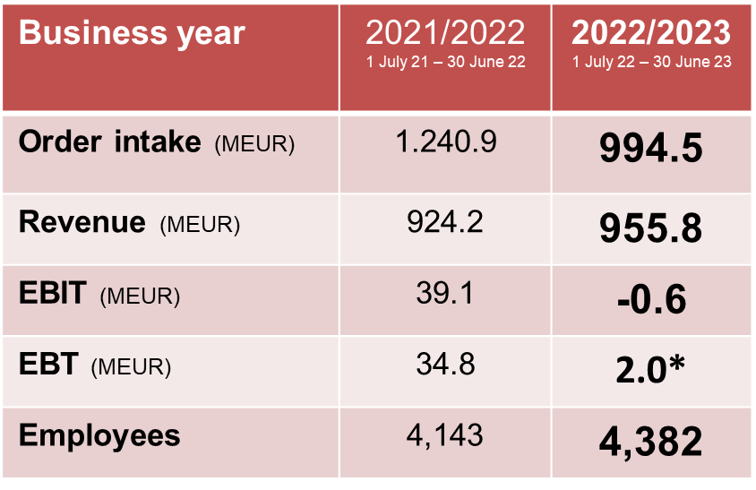

148 million dollars for the Upper Austrian location

Starting in the summer of 2024, TGW Logistics will be expanding its international headquarters in Marchtrenk, adding new offices, as well as production and storage areas. With this investment, the warehouse automation specialist is laying the foundation for future growth. Moreover, this expansion is a clear affirmation of the Upper Austrian location, and the commitment to the continued successful development of TGW Logistics.

Harald Schröpf is stepping down from his CEO function

Harald Schröpf has decided to step down from his function as Chief Executive Officer of TGW Logistics during the 2024 calendar year. He will remain in this position until the handover to an as-yet undetermined successor. Harald Schröpf stresses that:

"This was anything but an easy decision for me because I care deeply about TGW Logistics, our employees and our customers. Yet this step has been in the works for some time. Two years have already passed since I informed our owner, the TGW Future Private Foundation, of my desire to turn a new page and dedicate more time to my family and private interests. The Foundation and I are convinced that this change will give rise to a new dynamic and fresh motivation to continue to pursue and nurture the successful development that we have enjoyed these past years."

Under Harald Schröpf's leadership, the revenue of TGW Logistics increased from 657 to 1 billion dollars, and the number of employees rose from 2,776 to more than 4,400.

www.tgw-group.com
About TGW Logistics:
TGW Logistics is a leading systems integrator of automated warehouse solutions. With over 50 years of experience the automation specialist designs, manufactures, implements, and maintains end-to-end fulfillment solutions for brands such as URBN, the Gap, and TVH.

TGW Logistics has subsidiaries in the US, Europe, and China and employs more than 4,400 people worldwide. In the 2022/23 fiscal year, the foundation-owned company generated a revenue of $1 billion US dollars.

Pictures:
Reprint with reference to TGW Logistics free of charge. Reprint is not permitted for promotional purposes.

Contact:
TGW Systems Inc.
3001 Orchard Vista Dr SE STE 300, Grand Rapids, MI 49546
T: 616-970-7163
tgw@tgw-group.com

Press contact:
TGW North America:
Marissa Dierlam
Head of Marketing
T: 616-648-7738
marissa.dierlam@tgw-group.com

